Lab 2 Part 6

C:\Users\Jim03121957\OneDrive\Documents\GitHub\BCI

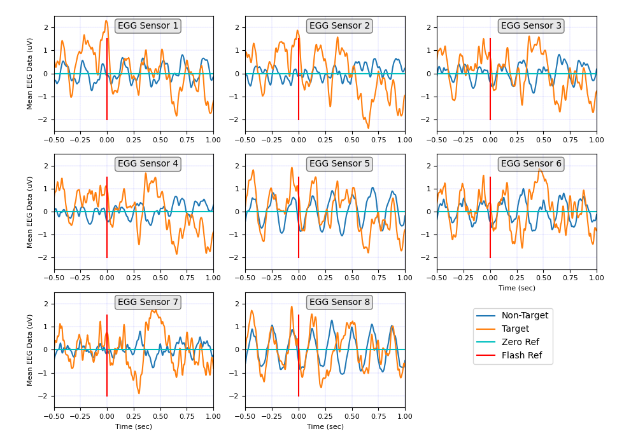Figure 1: Plot of P300 S3 Training ERPs. Shown is the mean of XXX realizations or epochs of target and non-target events. A target event occurs when the row or column flashed contains the target “Letter” of interest.

Why are the number of target erps the same as non-target erps?

Because that is the number of epochs.

But target row and target column flashes are 2/12 or 1/5th

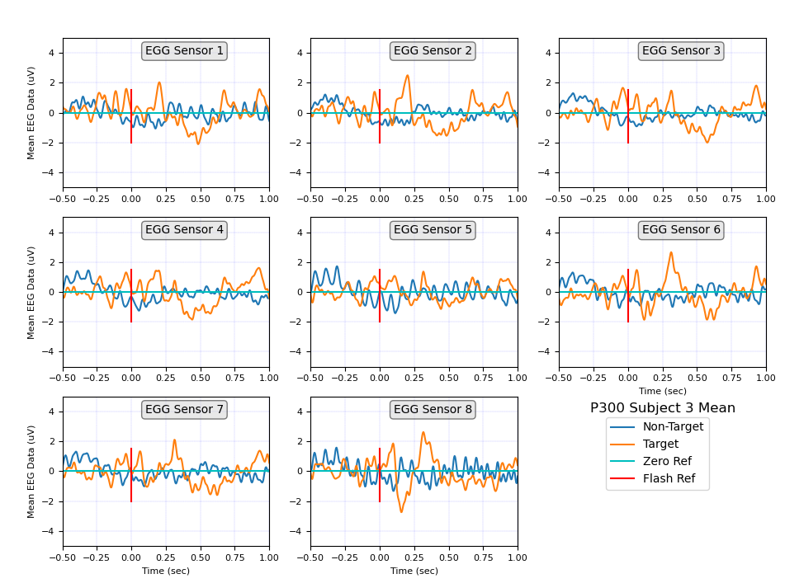

Comparing subject 3 when the number of non-target samples has been reduced to 150

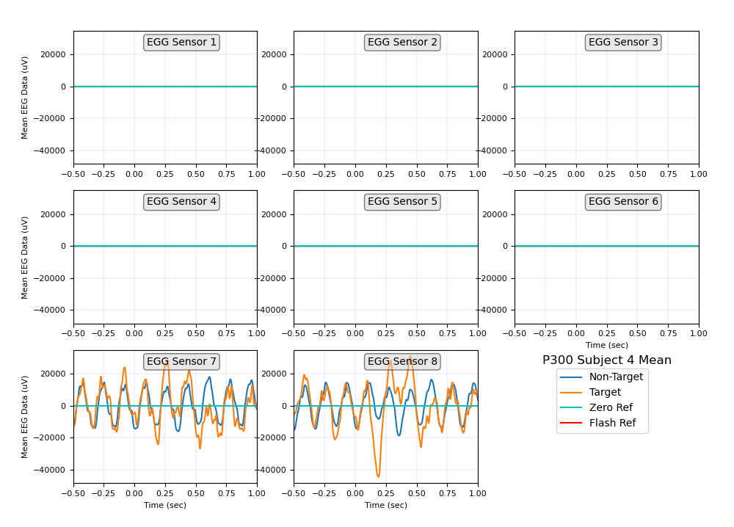Subject 4

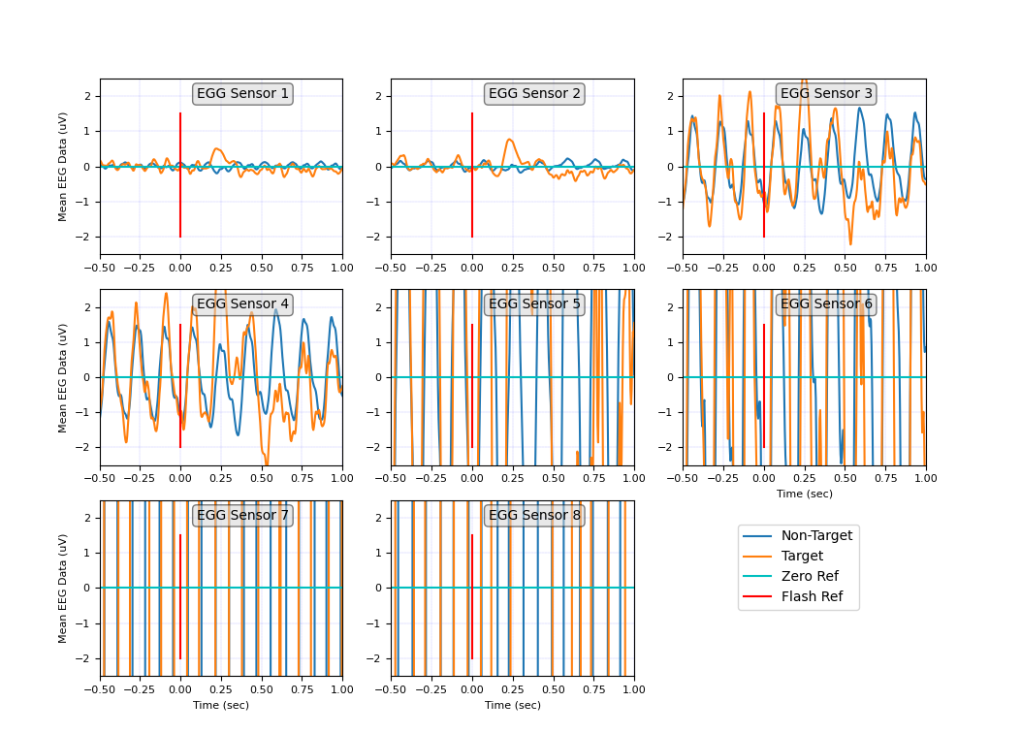Scale change on the y-axis

Max channel voltage (uV) Subject 4

23.421494618799876

10.433559437792866

50.49929844452106

44.05643056695413

432.831858238275

443.9412641716822

704680.072956882

397249.3700491111

Following data plotted with auto-scale for the y-axis. Plots look similar. Maybe the gain fro the different channels was not constant?

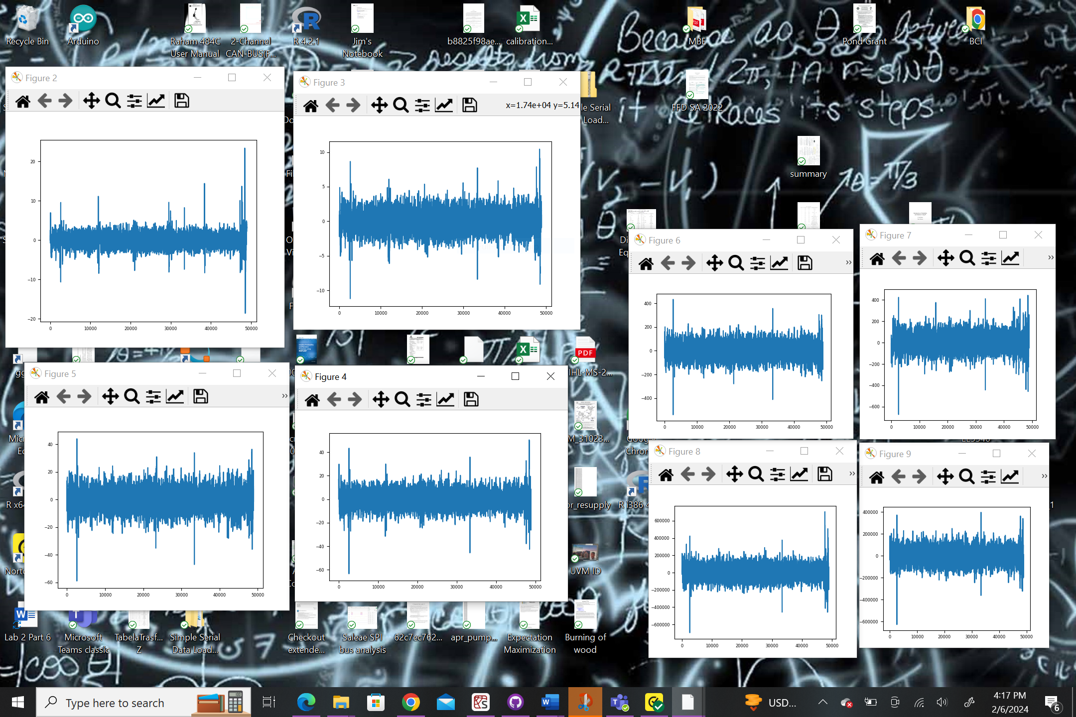

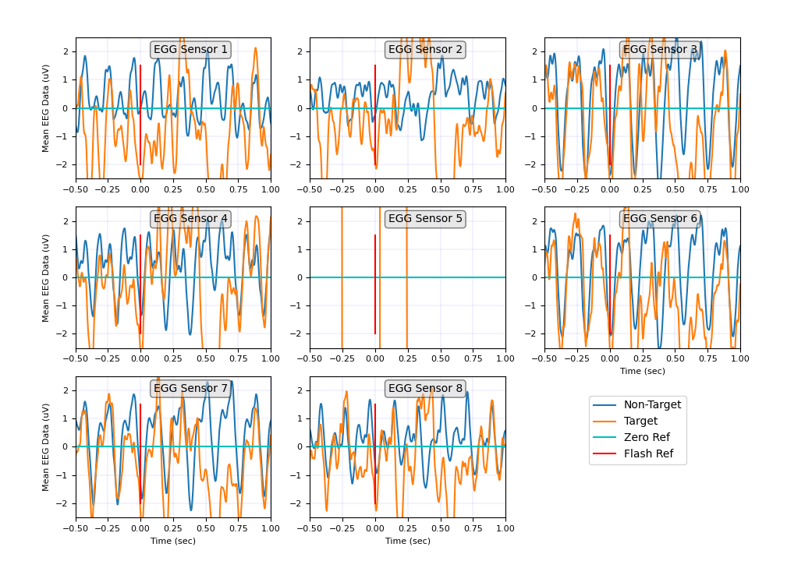Subject 5

Scale change on the Y-axis 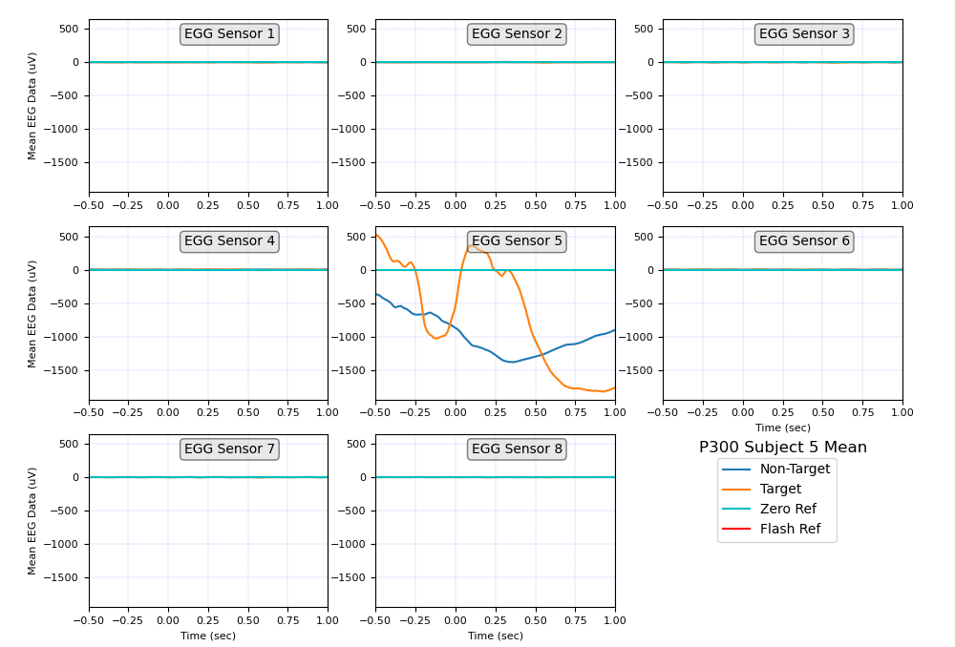

Raw data associated with subject 5 sensor 5

Raw data associated with subject 5 sensor 1-4 and 6-8 typical

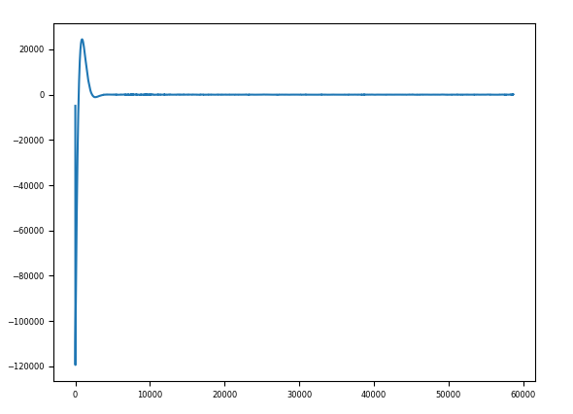

Looks like sensor 5 for subject sensed some artifacts for various time slots?

Subject 6

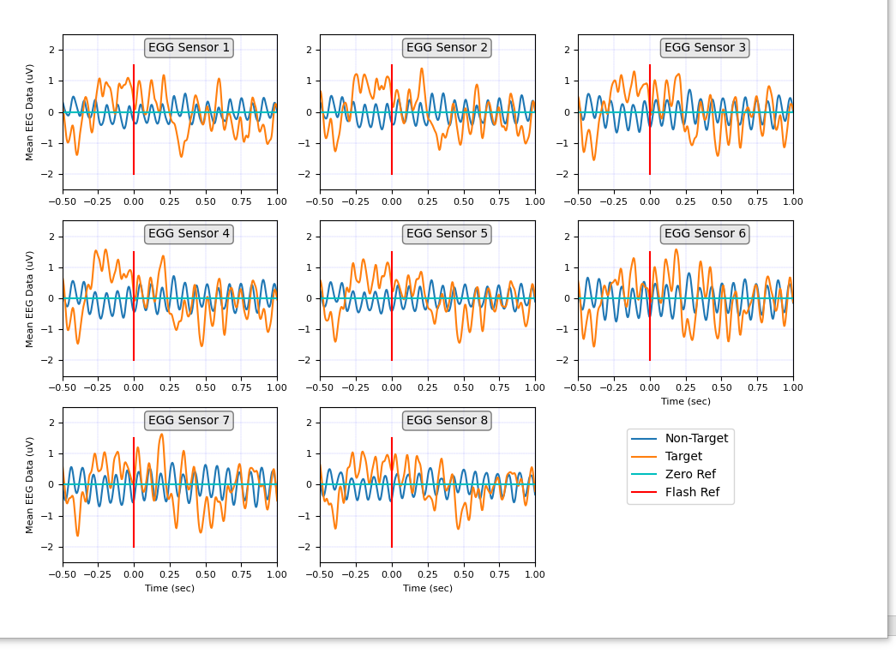

Subject 7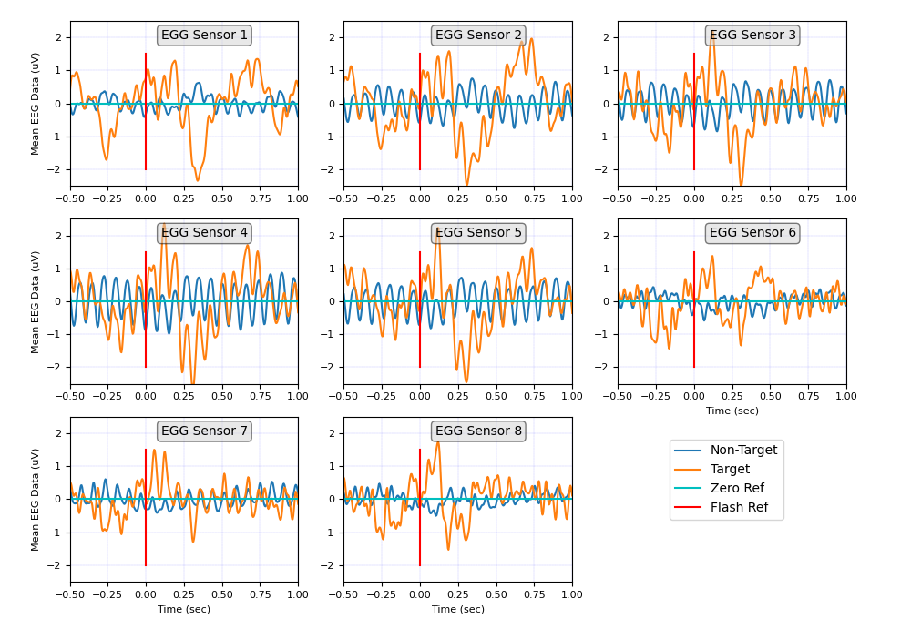

Subject 8

Subject 9

Subject 10

EEG Sensors 10/20 International sensor placement

|  |  |  |
| --- | --- | --- |
| EEG Channel | Sensor | Function |
| 1 | Fz | Frontal: Cognition |
| 2 | Cz |  |
| 3 | P3 | Parietal: Perception, attention |
| 4 | Pz |  |
| 5 | P4 |  |
| 6 | Po7 |  |
| 7 | Po8 |  |
| 8 | Oz | Occipital: Vision |

1. Why do we see repeated up-and-down patterns on many of the channels?
   1. Normal background brain activity.
2. Why are they more pronounced in some channels but not others?
   1. Location of the sensors pick-up different brain functionality
   2. How well the sensors are installed.
3. Why does the voltage on some channels have a positive peak around half a second after the flash?
   1. Recognition of the letter. Occipital senses the flash, then the parietal processes the information recognize, and counts.
4. Which EEG channels do you think these might be?
   1. Sensors associated with the measurement of vision occipital, perception parietal, and cognition frontal.
   2. As an example, Subject 10 sensors 6,7,8 have a peak around 100mSec, this is associated with a observing a flash associated with target letter, then a peak around 400mSec associated with processing, i.e counting
   3. Don’t understand why there is so much activity prior to the flash